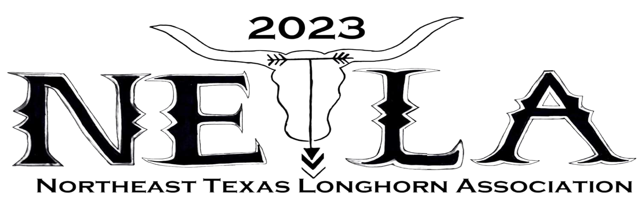
SALE SPONSORSHIPS

This is a sponsorship for the sale, June 3rd. Questions can be directed to Kyle James at kylejames2320@gmail.com, text message, or calling 610-451-0955. Checks should be made to NETLA and sent to Nelson Hearn, PO Box 421, Richland, PA. 17087.

Sponsorships are $150, $350, and $500. The $150 comes with a. half-page ad in the sale catalog; the $350 comes with a full-page ad in the sale catalog and a 2’x4’ banner displayed; and the $500 comes with a full-page ad in the sale catalog and a 2’X4’ banner displayed with mention of your company during the sale.

Breeder Sponsorships are Bronze $150 (receiving a half-page ad in the sale catalog and a 2’x2’ banner displayed. The Silver $350 (receiving a full-page ad in the sale catalog and a 2’x4’ banner displayed. The Platinum $500 (receiving a full-page ad in the sale catalog, one sale consignment, and a 2’x4’ banner displayed.

Sale Catalog Ads are available for $100 (full-page ad) and $60 (half-page ad). All ads must be ad ready.

All sponsorships and ads must be received by February 25, 2023

Business Name/RanchName_____________________________________________________________

Phone Number_________________________________________________________________

Address_______________________________________________________________________

Sponsorship Type: Corporate/Business__________ Breeder/Other_______________

